Types of Numeral
# Source: AI Source: Provided by: [Data Path: Persons Table -> ID Column: 1, Name_En Column: Motasem Essam] -> From: [Chatgpt (GPT-4-turbo)] on [7/28/2025]
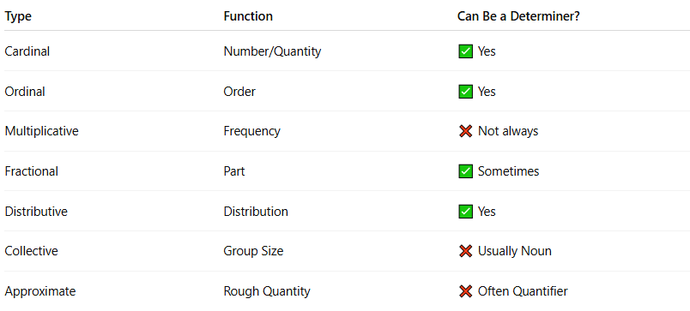

Type | Function | Can Be a Determiner?
Cardinal | Number/Quantity | ✅ Yes
Ordinal | Order | ✅ Yes
Multiplicative | Frequency | ❌ Not always
Fractional | Part | ✅ Sometimes
Distributive | Distribution | ✅ Yes
Collective | Group Size | ❌ Usually Noun
Approximate | Rough Quantity | ❌ Often Quantifier

